1. Using **ElementRef** in directive to manipulate the DOM is not a good practice as angular is also able to render your templates without a DOM and then these properties might **not be available**.
2. What is other way?
   1. There is some other helper you can inject, it’s the renderer.
3. 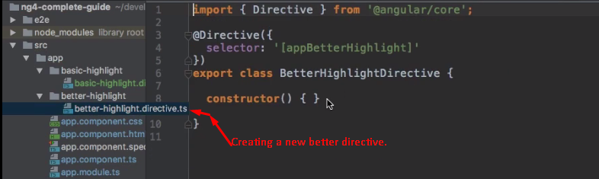  
   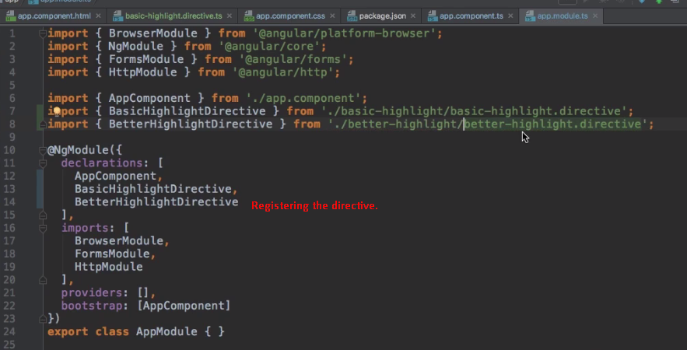
4. 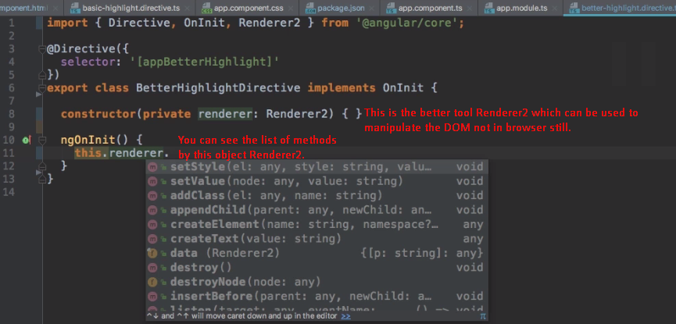
5. 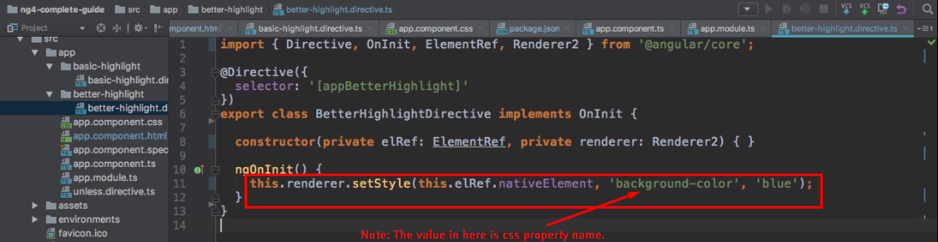
6. Why Renderer2 is better approach to access the DOM?
   1. Angular is not limited to running in the browser in here. For example, it also works with **service workers**. These are environments where you don’t have access to the DOM. You may get error in some circumstances if you try to access the DOM element in such environment as follows 